Executive Summary
The cleaned training dataset contains 53,992 unique residential property transactions (2016-2024) across 9 original raw transaction features, with 0% missingness in core fields (Price, County, Date). During processing, row_id and additional derived analytical features were created for validation and modelling. Routing-key missingness reduced from 68.70% to 32.60% (coverage increased from 31.30% to 67.40%; +36.10 percentage points) via address inference. Inference validation on known routing keys was based on 10,065 comparisons, with 349 mismatches, 3.47% error, and 96.53% accuracy. VAT Exclusive and IsSecondHand show a very strong practical association in cross-tab checks, with 0 observed rule violations. The dataset is suitable for modelling, with minor warnings on spatial granularity.
Evidence pointer: main.ipynb, Step 1 outputs (raw shape before and after dedup), Step 5.1 outputs (routing-key missingness before/after fill), and Step 5.1 validation outputs (10,065 compared; 349 mismatches; 3.47% error).

INTRODUCTION & SCOPE
Dataset: ppr-group-22312913-train.csv (raw: 54,000 → deduped: 53,992 rows)
Period: 2016-01 to 2024-12 (2,479 unique dates)
Features: 9 original raw transaction features (Date, Address, County, Eircode, Price, Not Full Market Price, VAT Exclusive, Description of Property, Property Size Description).
Processing outputs also include row_id and multiple derived features used for DQR/DQP and modelling.
Evidence pointer: main.ipynb, Step 1 raw column listing and Step 9 processed export structure.
Target: Price (€) – 6,689 unique values, range €5,587–€111M

Quality checks performed:
- Completeness: missingness by feature
- Accuracy: outliers, inference validation
- Consistency: VAT × property type crosstabs
- Validity: type conformity, constants
- Timeliness: temporal coverage

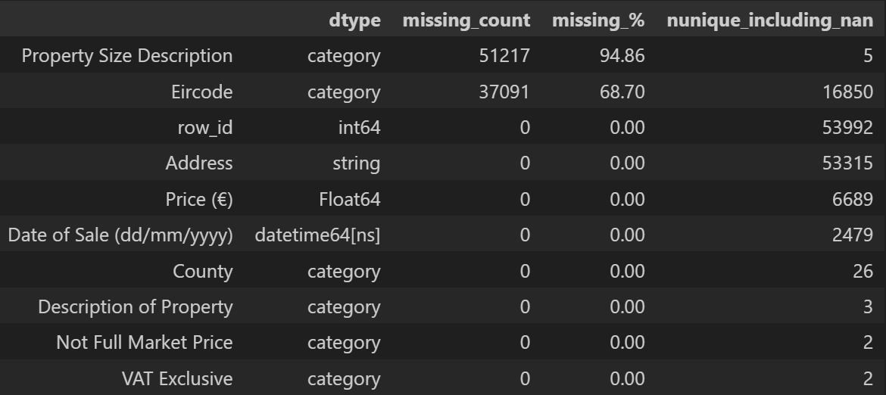

METHODOLOGY

Data Processing Pipeline (main.ipynb Steps 2-4):
1. Deduplication: 8 exact transaction duplicates removed
2. Parsing: Date (dd/mm/yyyy to datetime), Price (string to numeric euro value)
3. Categorical: County/flags → category dtype
4. Helpers: quality_overview(), numeric_summary()
5. Eircode: Routing key (first 3 chars) inference from 137-town reference
6. Validation: Inference accuracy on known routing keys

Key Decisions
- Address → cleaned (upper, alphanum only) for town matching
- Property desc → IsSecondHand boolean (TeachArasan→Second-Hand)
- No imputation beyond inference (preserve raw quality signals)
- Ambiguous routing keys (A82, A92) were excluded from county overwrite mapping to reduce erroneous county assignment.

Reproducibility Note: Results are environment-dependent. In particular, pandas categorical handling can vary across machine setups, which may affect intermediate processing behavior. To reproduce the reported values, run the notebook end-to-end in a single pinned environment and avoid mixing kernels or partial reruns.

COMPLETENESS
Core Features: 100% Complete
- Price: 0 missing, 6,689 unique values ✓
- County: 0 missing, 26 Irish counties ✓
- Dates: 0 missing, 2,479 timestamps ✓
- Flags: 100% (Not Full Market Price, VAT Exclusive)

Mitigation: Routing-key missingness reduced from 68.70% to 32.60% (coverage 31.30% to 67.40%; +36.10 percentage points).
Evidence pointer: main.ipynb, Step 5.1 outputs: Missing routing key before inference and Routing-key missing after fill.

ACCURACY
Price (€):
- Min: €5,587 | Max: €111,280,172 | Median: €250,000
- Distribution: Right-skewed (boxplot [Appendix Fig 1])
- Outliers: Valid (luxury/rural extremes)

Spatial Accuracy:
- County: Dublin 16,347 (30%), Cork 5,934
- Eircode Routing: Inference validation on known routing keys used 10,065 comparisons, with 349 mismatches (3.47% error; 96.53% accuracy).
Evidence pointer: main.ipynb, Step 5.1 outputs: Compared rows, Mismatch rows, Error rate.
- Dublin mismatches dominant (142 cases, address parsing)

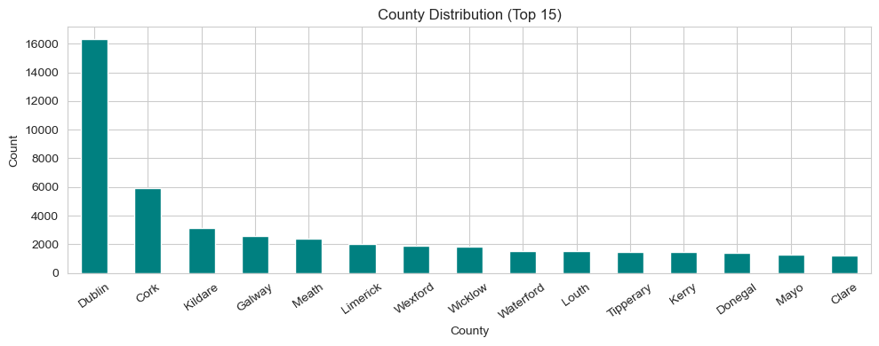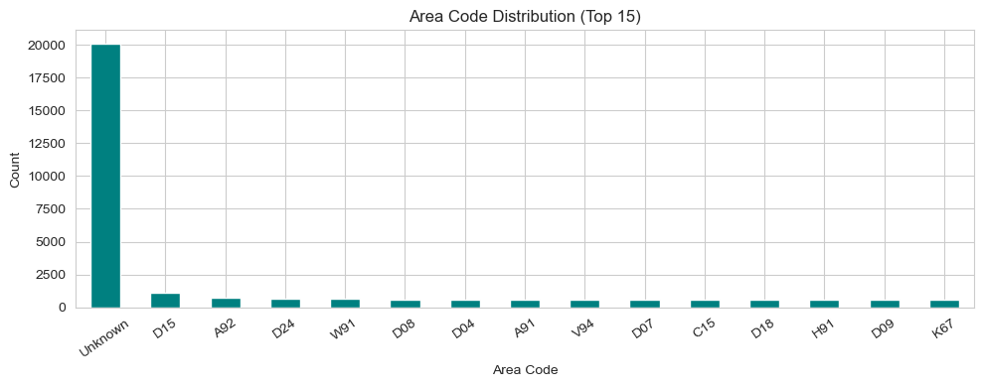

Temporal Accuracy:
- Coverage: 2016-2024 complete ✓
- Eircode missingness by year: 99.7% (2016) → 24.5% (2024)

CONSISTENCY
VAT Exclusive × IsSecondHand:

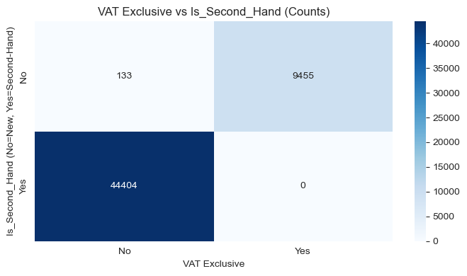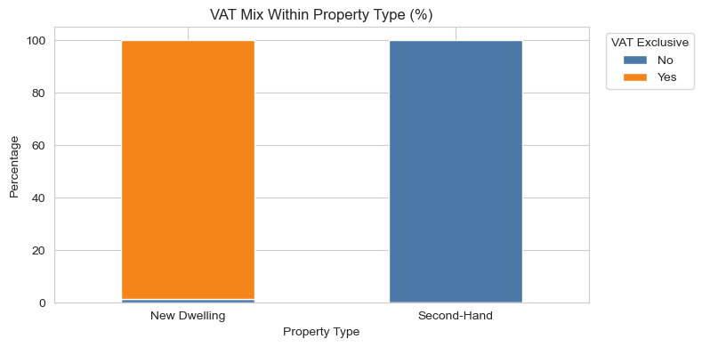

Key Findings:
- New homes: 98.61% VAT=Yes ✓
- 2nd hand: 100% VAT=No ✓ (0 violations)
- Association strength: VAT Exclusive and IsSecondHand show a very strong practical association in cross-tab checks (0 violations).
Evidence pointer: main.ipynb, Step 5.2 property description transformation outputs and Consistency cross-tab checks used in report calculations.

Implication: Redundant features (drop VAT Exclusive).

VALIDITY
Format Conformity:
- Price: All positive numeric ✓
- Dates: Valid datetime range ✓
- Flags: Binary (Yes/No) ✓
- No constants/duplicates post-cleaning ✓

Post-Conversion dtypes:
Date: datetime64 | Price: numeric dtype (float) | County: category ✓

TIMELINESS
Temporal Coverage: 2016-01 to 2024-12 (complete)
- 2,479 unique dates ✓
- Eircode adoption trend captured (99.7%→24.5% missing)
Evidence pointer: main.ipynb, Step 5.1 output: Eircode missing by year table.
Current as of Dec 2024 ✓

OVERALL ASSESSMENT
Strengths: Complete core features, very strong practical VAT consistency, full temporal span
Limitations: Eircode sparsity (mitigated), free-text sparsity

Data Quality Limitations: Address is free text and subject to spelling/format noise, which can affect routing-key inference and town matching. County-level geography remains coarse relative to local market variation, so some spatial heterogeneity is not captured. A residual share of routing keys remains unknown after inference, which limits granularity for some records.

Verdict: Suitable for ML – high quality target + geography ✓

RECOMMENDATIONS
Immediate (DQP):
1. Drop VAT Exclusive (redundant)
2. Use inferred routing keys (96.53% validation accuracy), with ambiguous A82 and A92 excluded from county overwrite.
3. Boolean IsSecondHand only

Future: External Eircode lookup for unmatched addresses

CONCLUSION
The dataset exhibits high quality suitable for price prediction modelling.

APPENDIX A: Key Notebook Evidence Table
Compact evidence table mapping each major claim to exact notebook outputs.
Claim Area | Exact Value Used | Notebook Evidence Pointer
Raw records loaded | 54,000 | Step 1 output: Raw train shape before dedup
Exact duplicates removed | 8 | Step 1 output: Raw duplicate rows on full signature
Final training rows | 53,992 | Step 1 output: Raw train shape after dedup
Missing prices | 0 | Step 4 output: Missing prices
Missing dates | 0 | Step 4 output: Missing dates
Price min / max | 5,586.84 / 111,280,172.00 | Step 4 outputs: Min price, Max price
Routing missing before / after | 68.70% / 32.60% | Step 5.1 outputs before and after fill
Coverage before / after | 31.30% / 67.40% | Derived from Step 5.1 missingness
Coverage gain | +36.10 percentage points | Derived from Step 5.1 coverage difference
Validation compared / mismatches | 10,065 / 349 | Step 5.1 outputs: Compared rows, Mismatch rows
Validation error / accuracy | 3.47% / 96.53% | Step 5.1 output + derived accuracy
Top mismatch county | Dublin (142) | Step 5.1 output: Top mismatch counties
County counts cited | Dublin 16,347; Cork 5,934 | Step 6 output: County frequency table
Eircode by year (2016 to 2024) | 99.7% to 24.5% missing | Step 5.1 output: Eircode missing by year
Ambiguous key safeguard | A82 and A92 excluded | Step 5.1 output: Ambiguous routing keys excluded

